der Nussknacker

Findest du den Weg
durch das Labyrinth?
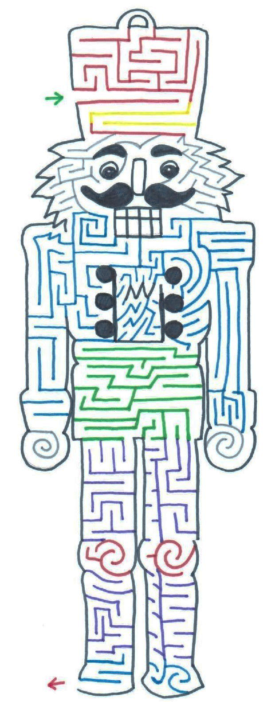
© 2020, German in the Afternoon
ENDE!
Hier anfangen!

Nussknacker Labyrinth
© 2020, German in the Afternoon

Nutcracker drawing & maze created by:

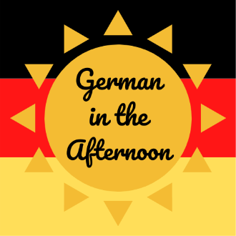

Font created by:



